Assessment of Breast Density Using Unsupervised Variational Autoencoders

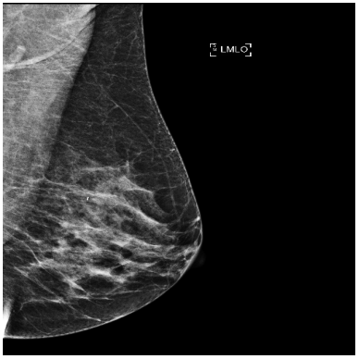

Su Kara

Cheryl Johnson

Capistrano Valley HS

Abstract

About 1 in 8 U.S. women will develop breast cancer in their lifetime. Breast density is a strong indicator for breast cancer. Women with extremely dense breasts have a sixfold greater risk of developing breast cancer. This study is about the assessment of breast density by using unsupervised deep learning algorithms. I trained a variational autoencoder algorithm on 6,987 patient mammograms without any manual annotations of the dense regions of the breast. With the use of the encoder model, I was able to predict the breast density as the ratio of the fibro glandular tissue to the whole breast accurately.

Introduction

About 12% of women in the U.S. will develop invasive breast cancer over the course of their lifetime (Breastcancer.org, 2021). The average 5-year survival rate for women with non-metastatic invasive breast cancer is 91%. Breast density is about the ratio of fibroglandular tissue (FGT) in a breast (Fig. 1), and it’s a strong indicator for breast cancer. Women with extremely dense breasts have a sixfold greater risk of developing breast cancer (Mandelson, 2000).

Fig 1. MRI showing FGT in a breast.

Screening mammograms do not find about 1 in 5 breast cancers. Women with dense breasts are more likely to get false-negative results. There are currently 4 categories of breast density ranging from almost all fatty tissue to extremely dense tissue with very little fat (Mayo Clinic Staff, 2020).

Diagnostic accuracy could be improved by calculating the breast density as a ratio of the fibro glandular tissue to the whole breast. Speed of diagnosis could be improved by using a deep learning algorithm rather than waiting for a radiologist to review the mammograms. Cost of diagnosis could be minimized by avoiding the need for additional and expensive procedures such as MRI and ultrasound for less dense breasts.

Background Research

Deep learning is part of a broader family of machine learning methods based on artificial neural networks with representation learning. Learning can be supervised, semi-supervised or unsupervised. There are similar medical applications such as supervised convolutional neural networks to assess breast density from mammograms. However, they’re either doing binary classifications such as dense or not dense (Lehman, 2018), or multi-class classification such as fatty, scattered, heterogeneous, or dense (Mohamed, 2018).

Those solutions don’t offer accurate information for breast density such as a specific ratio of the dense portion to the area of the breast. They also require annotations of images by radiologists to train their supervised learning algorithms.

Current proposed study will be a regression algorithm to make a solid prediction about the density of a breast in terms of a ratio of dense regions to the whole breast. Hypothesis of this study is that an unsupervised variational autoencoder (VAE) algorithm (Jordan, 2018) trained on mammograms without any annotation of breast or dense regions can generate accurate results for breast density.

Materials and Methods

In this study, 734 3D MRIs and 6,987 2D mammograms of 734 unique UCI patients were selected within the years from 2014 to 2019. For each MRI, mammograms of the same patient from the closest possible date have been used. These MRI and mammograms were anywhere from 1 week to 3 years apart.

The ground truth breast density was calculated by using the segmentations of FGT in the patient's MRI. The segmentation was done by a U-Net (Ronneberger, 2015), a variation of convolutional neural network (CNN), that was trained on the 30,464 MRI images. The breast MRIs have been resampled to a fixed 5mm slice thickness and 128x256x256 voxels. The breast mammograms have been resampled to 512x512. Both types of images were normalized by subtracting the mean and divided by the standard deviation of its respective image.

As part of image preprocessing, a separate U-Net segmentation algorithm was trained to mask the pectoralis section of breast on mediolateral oblique (MLO) images. This mask was later used to remove the armpit portion shown on breast mammograms.

Development environment included Python 3.6, TensorFlow 2.1.0, and Keras 1.0.8. The model was trained on 10 GeForce RTX Titan servers at the UCI lab.

VAE is a generative model that describes an observation in latent space (Fig. 2). The encoder network takes in an input image and converts it into a smaller representation. The decoder network converts it back to the original input.

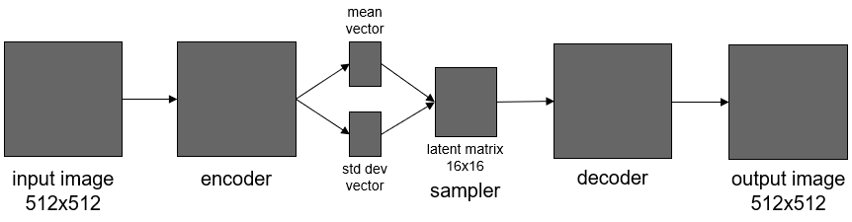Fig. 2. VAE architecture diagram.

The overall process can be summarized as follows:

* Train the VAE models on all mammograms
* Run encoder model prediction on each 512x512 input image (Fig. 3)
* Generate a 16x16 latent feature matrix for a patch shape of 32x32
* Clean up latent feature matrix by applying a mask from preprocessing
* Collapse masked latent matrix into a single value such as mean, median, 25th, or 75th percentile
* Correlate them with the FGT/breast ratios from U-Net on MRIs

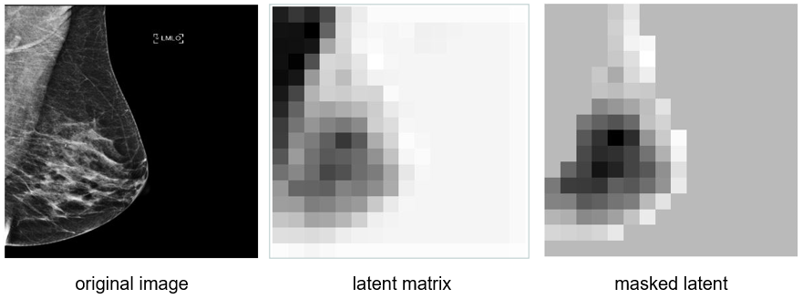Fig. 3. Encoder model prediction turns original image into a latent matrix that gets masked.

The VAE algorithm training was initialized from random weights. Optimization was implemented via the Adam method with a learning rate of 0.001 and a batch size of 4. Latent dimensions ranged from 1 to 10. Approximately 20,000 iterations were required for algorithm convergence.

Analysis and Results

Training completed in 30 minutes by running 10 different combinations of models on 10 GPU servers in parallel. Running the encoder model prediction on all images took 2 minutes for each model, latent dimension, and latent index combination.

The original image was broken into 32x32 patches to learn more about the contrast within the image, which represented the FGT regions inside the breast. When the latent dimension was set to 1 to learn only one feature, the decoder images clearly showed the contrast changes from light to dark colors (Fig. 4). However, it also learned about edges in addition to contrast. With the increasing number of latent dimensions, the model started learning more complicated features such as curves and breast shapes.

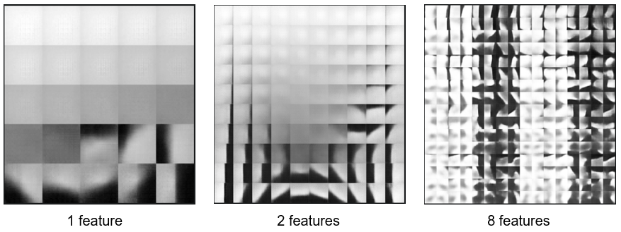Fig. 4. Decoder predictions for different latent dimensions.

Masked latent matrix was collapsed into a single value by calculating the mean, median, 25th, and 75th percentile. Each of these parameters was correlated with the FGT/breast ratio to find the best performing parameter. The *mean* turned out to be the parameter in 4 of the top 5 performing results (Table 1).

Table 1. Top five performing latent dimensions and parameters with corresponding correlations.

|  |  |  |
| --- | --- | --- |
| Latent Dimension | Parameter | Pearson Correlation |
| 10 | mean | 0.68 |
| 9 | mean | 0.67 |
| 8 | mean | 0.67 |
| 10 | mean | 0.66 |
| 10 | 75th percentile | 0.66 |

Even though decoder predictions showed more clear distinction between FGT and breast in lower number of features, somehow higher latent dimensions resulted in higher correlation. The model must have been learning more about contrast in those additional features.

Pearson correlation between the mean of masked latent and the ground-truth FGT/breast ratio was calculated as 0.68. Linear regression showed a mean absolute error of 0.05. The breast density (FGT/breast ratio) shown as the output *y* can be calculated by using the following formula, where the input *x* stands for the mean of masked latent: *y* = 0.23*x* + 0.38 (Fig. 5)

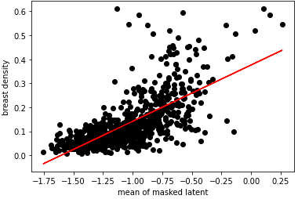

Fig 5. Linear regression between the mean of masked latent and breast density.

Since the relationship is linear, a new formula could be developed by shifting the minimum to zero and dividing the *mean* by the range of 2 between min and max to find the breast density such as *y* = (*x* + 1.75) / 2. In other words, there is no need to use the FGT/breast ratio from the MRI U-Net. It is used only to see whether there is a strong correlation and to prove the linearity.

The data supports the hypothesis that an unsupervised deep learning algorithm such as VAE can be used to predict breast density. Even though supervised algorithms such as regular CNN and U-Net models still provide higher accuracy, radiologists need to spend a lot of time to annotate MRIs, CT scans, and mammograms manually. Unsupervised techniques will be the next breakthrough in the use of AI in medical diagnosis as there will be no need to annotate images anymore. This study proves that new unsupervised techniques can be used to address some of the current medical diagnosis needs of radiologists.

References Cited

Breastcancer.org. (2021, February 04). U.S. breast cancer statistics. Retrieved February 19, 2021, from https://www.breastcancer.org/symptoms/understand_bc/statistics

Jordan, J. (2018, March 19). Variational autoencoders. Retrieved February 19, 2021, from https://www.jeremyjordan.me/variational-autoencoders/

Lehman, C., Yala, A., Schuster, T., Dontchos, B., Bahl, M., Swanson, K., & Barzilay, R. Author (2018, October 16). Mammographic breast density assessment using deep learning: clinical implementation. Radiology 2019; 290:52–58. https://doi.org/10.1148/radiol.2018180694

Mandelson, M., Oestreicher, N., Porter, P., White, D., Finder, C., Taplin, S., & White, E. (2000, July 05). Breast density as a predictor of mammographic detection: comparison of interval- and screen-detected cancers. JNCI: Journal of the National Cancer Institute, Volume 92, Issue 13, 5 July 2000, Pages 1081–1087. https://doi.org/10.1093/jnci/92.13.1081

Mayo Clinic Staff. Dense breast tissue may increase the risk of breast cancer. (2020, February 18). Retrieved February 19, 2021, from https://www.mayoclinic.org/tests-procedures/mammogram/in-depth/dense-breast-tissue/art-20123968

Mohamed, A.A., Berg W.A., Peng H., Luo Y., Jankowitz, R.C., & Wu, S. (2018, January) A deep learning method for classifying mammographic breast density categories. Med Phys. 2018 Jan;45(1):314-321. https://doi.org/10.1002/mp.12683

Ronneberger, O., Fischer, P., & Brox, T. (2015, May 18). U-Net: Convolutional networks for biomedical image segmentation. Retrieved February 19, 2021, from https://arxiv.org/abs/1505.04597